Anomalous Fluctuation of RNG DATA IN Nebuta: summer festival in northeast japan
Tatsu Hirukawa & Masato Ishikawa
School of Information and Communication
Meiji University
Tokyo, Japan
Abstract
This paper describes a pilot study investigating the mind-matter interaction during the Japanese traditional festival. On August 2nd and 3rd, 2003, fluctuation of RNG was measured in the first night of Aomori-Nebuta, one of the most popular folk festivals in northeast Japan. In 6-day festival, around 600 thousand people gathered every nebuta night and enjoyed singing and dancing with rhythmical drums, like carnivals in Latin American countries. Authors expected to find some significant deviation of the field RNG in this festival, particularly because some yakuza (Japanese gang)-like groups called karasu (crow) become so excited that they sometimes turn into violent mobs, that is, mass emotional excitement may effect the outputs of RNG. The hypothesis that the deviation in the RNG data appears during the festival period was tested by the cumdev and windowing methods. By the cumdev method, significant deviation was obtained in the overall accumulation of chi-square values during the 110-minute festival period (18:50-20:40, Aug. 2nd): Z²-1=200.1, p=0.041 (one-tailed; df=6600). However, accumulation of Stouffer Z value during the same period showed no significant deviation: Z=1.00, p=0.32 (two-tailed). In the windowing method, three different sizes of window width (15, 30, and 60 minutes) are used for analyzing the 19-hour data from 11 am (Aug. 2nd) to 7 am (Aug. 3rd). Each highest peak of window-shifting accumulation of chi-square value in the three different windows was found in the festival period, which is significant: in 19:45-19:59, Z²-1=106.5, p=0.0075 (one-tailed; df=900); in 19:30-19:59, Z²-1=140.0, p=0.0111 (df=1800); in 19:00-19:59, Z²-1=202.6, p=0.0093 (df=3600). All the ends of peak windows are the same (19:59). On the other hand, each highest peak of the absolute value of Stuffer-Z in three different windows was also significant but found at the end border of festival period: in 20:45-20:59, Z=-2.409, p=0.0160 (two-tailed); in 20:30-20:59, Z=-2.187, p=0.0288; in 20:00-20:59, Z=-2.355, p=0.019. Just as the result of chi-square deviation, all of the ends of highest windows are the same (20:59). The overall results suggest the field RNG analyses on local festivals are promising. More data are required for proving the hypothesis and discussing correlates between the RNG deviation and a variable such as the number of participants.

Introduction
This paper describes a pilot study investigating the mind-matter interaction during the Japanese traditional festival. Its aim is to check if the field RNG analyses on local festivals are promising or not.

Field RNG
The previous researches suggest that the mind-matter interaction may occur, when a large number of people form a shared emotion, a shared attention, or a specific state of consciousness. The researches are referred to as FieldREG (Nelson et al., 1996; Nelson et al., 1998) or field consciousness (Radin, 1997; Radin, 2002). The mind-matter interaction seems to be found as deviation on a random number generator (RNG), or a random event generator (REG), in which a logical XOR (eXclusive-OR) guarantees zero deviation in the long run (Ibison, 1998; Nelson, 2001).

Significant RNG deviation was often reported during some meetings (Nelson et al., 1996), broadcasting events (Radin et al., 1996), and sport events (Bierman, 1996). The Global Consciousness Project (Nelson, 2001) built a worldwide network of RNGs connected by Internet. The authors keep an RNG site running, which is the only site of GCP in Japan as of today. The GCP data showed significant deviation during some global events such as New Year, World Cup Soccer, and the Olympics. The most prominent results were obtained by the data of September 11, 2001 (Radin, 2002; Nelson, 2002).

To reveal the properties of mind-matter interaction, further research results on local events as well as global events are required, because a distinct shared emotion and attention are found in different cultural backgrounds.

Particularly, indigenous festivals and religious rituals are important topics, because participants of such ceremonies usually share a special state of consciousness and may experience psi-related phenomena. Nelson et al. (1998) review some results measured in such situations as healing rituals of native American and "paganist" ceremonies. In Japan, many kinds of festivals and rituals have been held in the long tradition of the complex syncretism of native animism, shamanism, Shintoism, and Buddhism. Even today, this syncretic worship for gods, spirits, and ghosts are popular among Japanese people. Yoichi et al. (2002; 2004) gathered RNG data focusing on Japanese New Year festivals, and Kokubo et al. (2002; 2004) researched “haunted houses” (i.e. RSPK cases) in Japan. They reported some significant results.

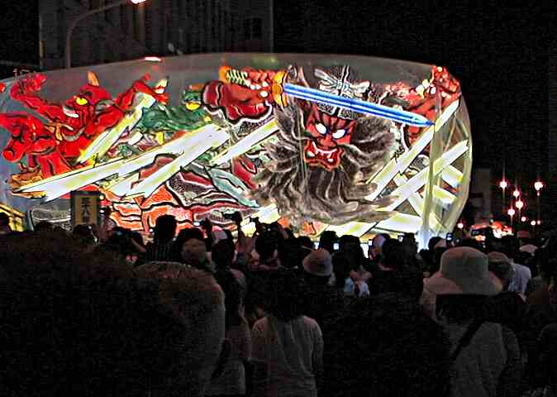
Fig. 1 A nebuta of the thunder-god swinging his sword. Each nebuta features fighting samurais or rough gods representing awful power of the nature. All nebutas were covered with plastic sheets because it was drizzling at the first night of the last festival. (Aomori, Japan)

Nebuta Festival
Aomori-Nebuta held in Aomori (140:44' E, 40:49' N), a northernmost city in mainland Japan, is one of the most popular summer festivals in Japan. During 6-night festival in every summer, nebutas, huge illuminated figures representing local gods and legendary samurais (Fig. 1) go round the streets in central Aomori city. Like the carnivals in Latin American countries, 2000 hanetos (jumping [wo]men) dance around each of a dozen of nebutas with repeating 4-beat rhythm: “lasseh-lah”, and people release their “energy repressed for a year” –– particularly for long gloomy winter. Many people also come to join the festival from other cities and even from foreign countries to be not only spectators but also hanetos. Last summer, around 600 thousand people gathered at the center of Aomori city every nebuta night (around from 7 to 9 pm). During and after the festival, people stop in stalls and bars to buy souvenirs, to eat and to drink. Most people go back to their home until around 11 o’clock in the midnight before the last train leave Aomori station and bars and restaurants close. Few people wander around the street for overnight. However, during the festival, some yakuza (Japanese gangster) -like group of hanetos become so excited that they sometimes turn into violent mobs. They are called “karasu (crow) haneto”, or simply “karasu” because of typically wearing black kimono, and regarded as a social problem in the area (Anami, 1999) (Fig 2). Although the origin of the festival is not clear, people have celebrated their short summer for hundreds of years. According to the historical record, many people have been injured and even killed during the festival of every summer.


Fig. 2 “NO! Just say NO!! Stop the KARASU! If you play karasu, you must be punished by the law! Last year, 5 people were arrested!” Every summer, we can see many warning posters distributed by Aomori local police. Karasus typically ware black or yakuza (Japanese gang) -styled kimonos or tokko (kamikaze fighter) clothes. (Aomori, Japan)

Methods
Equipment
A portable computer controls Orion (http://www.randomnumbergenerator.nl/), where a sequence of random numbers are generated and transmitted through its RS232C port. Sampling software FRED (see acknowledgments) records 200-bit random numbers per second; every bit (0 or 1) is summed up for a second to make a value N whose MCE is 100 and VAR is 50. Each number N is normalized to Z score: Z = (N-100) / sqrt(50). The Z scores are analyzed using MS-Excel and statistics software SPSS.

Measurement
Hirukawa, the first author, measured RNG data during the last Aomori-Nebuta festival on August 2nd 2003, the first day of the 6-day festival. On the day, nebutas went round the center of Aomori city around from 18:50 to 20:40 (Japan Standard Time). RNG data were recorded from 11 am of 2nd to 7 am of 3rd in a room of a hotel located about 300 meters apart from the city center where the nebutas went around. There was no person in the room during the festival to minimize the experimenter effect, although Hirukawa slept in the room from 0 to 7 am of 3rd. No data were recorded from 23:00 to 23:59 due to check the computer.

No special event or accident occurred in the period other than the festival although the stuffs prepared for it from the morning. No one was killed or severely injured during the festival of the night under the strict control by local police (Anami, pers. comm.).

Hypotheses
The only explicit hypothesis we posit is the same as other researchers' (e.g., Bierman, 1996; Yoichi et al., 2004).

The deviation in the RNG will appear during the festival period while the RNG will operate randomly during the other periods, where the deviation means that significantly more 1s/0s are generated than the mean chance expectation. The deviation is specified by the combination of Z scores, each of which is calculated by the occurrence of 1s and 0s in a second.

Analyses
To test the hypothesis shown above, we employed two types of analyses: cumdev and windowing (Radin et al., 2003). The cumdev method evaluates the deviation, accumulating per-second Z scores over the whole period. The windowing method compares the deviation in smaller width of time windows. In both methods, each per-second Z score is combined into longer periods of time: (1) as a change in variance in the form of an N-time sum of Z²-1 (MCE=0; VAR=2N), which corresponds to the chi-squared distribution with degrees of freedom (df) equal to the number of seconds, N, or (2) as a mean-shift in the form of Stouffer Z, which corresponds to the simple combination of Z scores.

Results
Cumdev
The fluctuation of RNG outputs during the festival is analyzed by the cumdev method. Its purpose is to check if any significant deviation is found during the festival period in comparison with the mean chance. The following two line graphs show cumulative deviation of chi-square (Fig. 3) and mean-shift (Fig. 4). Each graph accumulates three sets of 110-minute data: during the festival period (18:50-20:40 JST), just before the period (17:00-18:50 JST), and just after the period (20:40-22:30 JST). The before-festival and after-festival data are treated as controls.

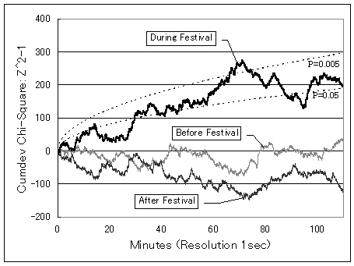
Fig. 3 Cumulative chi-square deviation of RNG data during and around Nebuta festival

In Fig. 3, the cumulative chi-square curves are shown. The y-axis is N-time sum of Z²-1, where N corresponds to the number of seconds and df. The dotted lines are the border of significant p values, which is calculated by the approximation of standard distribution whose MCE is 0 and VAR is 2N. The during-festival curve goes up to the highly significant level at the middle of the festival period; the overall value in the 110-min period is Z²-1=200.1, p=0.041 (one-tailed; chi-square, df=6600). The control curves are not significant.

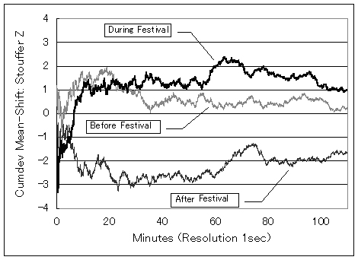
Fig. 4 Cumulative mean-shift of RNG data during and around Nebuta festival

In Fig. 4, the cumulative mean-shift curves are shown. The y-axis is Stouffer Z, the simple combination of Z score of each second. The during-festival curve shows that more 1s were generated in the former half of the festival period than 0s, while less 1s were generated in the latter half. The overall value in the 110-min period is not significant: Stouffer Z=1.00, p=0.32 (two-tailed). The control curves are not significant as well.

Windowing
The deviation of RNG outputs is analyzed by the windowing method. Its purpose is to check if any significant deviation is found during the part of festival period in comparison with the other periods. The following two bar graphs show changes of chi-square (Fig. 5) and mean-shift (Fig. 6). Three different sizes of windows are arbitrarily decided and used in this analysis: 15, 30, and 60 minutes. For example, the left-most bars are the accumulation from 11:00:00 to 11:59:59 in 60-minute window, from 11:00:00 to 11:29:59 in 30-minute window, and from 11:00:00 to 11:14:59 in 15-minute window. There is no data from 23:00 to 23:59 because of the computer check.

Fig. 5 Chi-square deviation of RNG data in 15, 30, and 60-min windows

In Fig. 5, although some bars show significant deviation not only within the festival but also in other periods, each highest bar of three different windows is found within the period of the festival (18:50-20:40). All peaks are significant in 5-percent level, and all the ends of peak periods are the same (19:59) [see Table 1]. After 20 o'clock, the latter half of the festival, chi-square values go down below zero.

Table 1 Accumulation of Z²-1 values of the highest bars in 15, 30, and 60-min windows
WindowTimeSum (Z²-1) dfp (one-tailed)
15 min.19:45 - 19:59106.5 9000.0075
30 min.19:30 - 19:59140.018000.0111
60 min.19:00 - 19:59202.636000.0093

Fig. 6 Mean-shift of RNG data in 15, 30, and 60-min windows

In Fig 6, just as the result of chi-square deviation, each highest bar of three different windows is significant in 5-percent level and all of the ends of peak periods are the same (20:59) [see Table 2]. However, this result is marginal, because the festival itself officially ended at 20:40. The highest value of 15-min window is found just after the festival.

Table 2 Stouffer Z and (Stouffer Z)² values of the highest bars in 15, 30, and 60-min windows
15 min. 20:45 - 20:59-2.4095.8030.0160
30 min. 20:30 - 20:59-2.1874.7820.0288
60 min. 20:00 - 20:59-2.3555.5450.0185

Window Time Stouffer Z (Stouffer Z)² p (two-tailed)

Conclusion and Discussion
Significance of the results
The chi-square analysis resulted in the significant deviation during the festival period in comparison with the mean chance and the other periods. The cumdev method showed significant chi-square deviation in the festival period (Z²-1=200.1, p=0.041). The windowing method located the most deviated chi-square peaks at the middle of festival period, when using 15, 30, and 60-min windows.

The mean-shift analysis resulted in no significant deviation during the festival period, but found some characteristic deviation just after the festival period. The cumdev method did not show any significant Stouffer-Z deviation in the festival period (Stouffer Z=1.00, p=0.32). The windowing method located the most deviated Stouffer-Z peaks at the end of festival period, when using 15, 30, and 60-min windows.

Overall the results are partly affirmative to the hypothesis, but to prove it, more field RNG analyses on some local festivals should be repeated. The results suggest such analyses are promising.

Future Research
We found much deviation of Stouffer Z in the latter half and just after the festival, while the accumulation of Z²-1 changed to negative values in the same period. This seems a paradoxical result. However, we don't have enough data to generalize it as a common trend in this kind of field RNG experiments. More data are needed for further discussion such as correlation between the RNG deviation and the number of participants, or the types of emotion etc. Nebuta is not a very sacred ritual related to any religious cult, but a festival in folk society. We have already collected and are now analyzing the RNG data of other religious festivals in Japan, such as Osorezan-Taisai: a yearly ceremony to appease dead spirits by Buddhist monks (northeast Japan) and Onbashira-Matsuri: a ritual for the renewal of guarding wood pillars around Suwa Grand Shrines (central Japan).

Acknowledgments
Authors thank Dr. Dean Radin for allowing us to use a beta version of Field REG Device (FRED) code and Prof. Toru Anami, specialist of Nebuta folklore, for his helpful advice. We also thank Ms. Hiroko Hagiwara for her help.

References
Anami, T. (1999). Aomori nebuta to karasu haneto (Aomori nebuta and karasu haneto). Shukusai no Hyaku-nen (One Hundred Years of the Festivals). Tokyo: Domes. (In Japanese)
Bierman, D. J. (1996). Exploring correlations between local emotional and global emotional events and the behavior of a random number generator. Journal of Scientific Exploration, 10, 363-373.
Ibison, M. (1998). Evidence that anomalous statistical influence depends on the details of the random process. Journal of Scientific Exploration, 12, 407-423.
Kokubo, H., Yamamoto, M. & Hirukawa, T. (2004). Case report on strange electro-magnetic signals: Research of "poltergeist" incident in Gifu, Japan. Livro de Registiro de Trabalhos Apresentados, 2 Encontro Psi, Refletindo Sobre o Futuro da Parapsicologia (Proceedings of the Works of Presentators, 2nd Psi Meeting: Reflection to the Future of Parapsychology), 66-75. Curitiba: Faculdades Integradas „Espírita”
Kokubo, H., Yoichi, H. & Yamamoto, M. (2002). Data analyses of a field number generator. The Japanese Journal of Parapshychology, 7, 11-16. (In Japanese)
Nelson, R. D. (2001). Correlation of global events with REG data: An Internet-based, nonlocal anomalies experiment. Journal of Parapsychology, 65, 247-271.
Nelson, R. D. (2002). Coherent consciousness and reduced randomness: Correlations on September 11, 2001. Journal of Scientific Exploration. 16, 549-570.
Nelson, R. D., Bradish, G. J., Dobyns, Y. H., Dunne, B. J. & Jahn, R. G. (1996). FieldREG anomalies in group situations. Journal of Scientific Exploration, 10, 111-141.
Nelson, R. D., Jahn, R, G., Dunne, B. J., Dobyns, Y. H. & Bradish, G. J. (1998). FieldREG II: Consciousness field effects: Replications and explorations. Journal of Scientific Exploration, 12, 425-454.
Radin, D. I. (1997). The conscious universe. San Francisco: HarperEdge.
Radin, D. I. (2002). Exploring relationships between random physical events and mass human attention: Asking for whom the bell tolls. Journal of Scientific Exploration, 16, 533-548.
Radin, D. I., Rebman, J. M. & Cross, M. P. (1996). Anomalous organization of random events by group consciousness: Two exploratory experiments. Journal of Scientific Exploration, 10, 143-168.
Radin, D. I., Taft, R. & Yount, G. (2003). Possible effects healing intention on cell cultures and truly random events. Proceedings of the 46th Annual Convention of the Parapsychological Association. 162-183.
Yoichi, H., Kokubo, H. & Yamamoto, M. (2002). Anomaly of random number generator outputs: Cumulative deviation at a meeting and New Year's holiday. Journal of International Society of Life Information Science, 20(1), 195-201.
Yoichi, H., Kokubo, H. & Yamamoto, M. (2004). Anomaly of random number generator outputs (II): Cumulative deviation at New Year's holiday. Journal of International Society of Life Information Science, 22(1), 142-146.

