Field REG Experiments of Religious Rituals and Other Group Events in Paraná, Brazil.

Tatsu Hirukawa¹, Reginaldo Hiraoka^{2,3}, Fábio Eduardo da Silva³, Sibele Pilato³, and Hideyuki Kokubo^{4,1}

(1) School of Information and Communication, Meiji University, Tokyo, Japan.
(2) Instituto Nacional de Pesquisas Psicobiofísicas, Faculdades Integradas “Espírita”, Campus Universitário Dr. Bezerra de Menezes, Curitiba, Brazil.
(3) Centro Integrado de Parapsicologia Experimental, Faculdades Integradas “Espírita”, Campus Universitário Dr. Bezerra de Menezes, Curitiba, Brazil.
(4) International Research Institute, Chiba, Japan.

Abstract

We measured the fluctuations of data from REGs, or “field consciousness” in the religious rituals and other events in Paraná, Brazil. The rituals and events we investigated are the ceremonies of Guarani people, Umbanda, Santo Daime, table turning, samaritano and other group healing, Candomblé, yoga class, and a concert of Djavan. To using the method of accumulation of (Z²-1), we found 4 significant deviations (in 5% level) in 18 experiments and 2 significant deviations in 8 controls for distance. To using simple Z score, we found 1 significant deviation in 18 experiments and 1 significant deviation in 8 controls. The average of normalized accumulations of (Z²-1) from experimental data was larger than the average of controls for distance, although it was not significant. The normalized accumulations of (Z²-1) of experimental data were not correlated with the numbers of participants of the events. Whether the total deviations were significant or not, mountain shaped graph (“up, up, and down” pattern) like “decline effect” in PK experiments were commonly observed in the analyses of accumulation of (Z²-1).

Introduction

This paper describes a pilot study investigating the fluctuation of “field consciousness” mainly during the religious rituals.

REG Research
The REG (Random Event Generator) or RNG (Random Number Generator) which makes random number based on quantum mechanics have been used for the experiments to detect “micro-PK” for a half century. Meta-analyses of many experiments show weak but significant results (Radin, 1997: 138-144; Blackmore, 2003: 298-301). The results may have essential importance to solve the theory of measurement in quantum mechanics, to understand the nature of mind-matter relationship.

Field REG
Recently some researchers start to investigate the fluctuation of "field consciousness" (Radin, 1997: 157-174) or “physical entropy”. The previous researches suggest that the mind-matter interaction may occur, when a large number of people form a shared emotion, a shared attention, or a specific state of consciousness. The researches are referred to as FieldREG (Nelson et al., 1996; Nelson et al., 1998) or “field consciousness” (Radin, 1997; Radin, 2002). Significant REG deviation was often reported during some meetings (Nelson et al., 1996), broadcasting events (Radin et al., 1996), and sport events (Bierman, 1996). Particularly, religious rituals and ceremonies are important topics, because participants of such ceremonies usually share altered states of consciousness and may experience PK-related phenomena like anomalous healing. Nelson et al. (1998) review some significant results measured in such situations as healing rituals of Native American and "paganist" ceremonies. Hirukawa and Ishikawa (2004) found significant fluctuation of REG data during Nebuta-matsuri, summer festival in northeast Japan. Yoichi et al. (2002; 2004) gathered REG data focusing on Japanese New Year festivals. They reported some significant results.
In this study, we focus on the religious rituals in Brazil because Brazil is one of the richest places of various religious movement and musical tradition from the indigenous culture to complex syncretism of the immigrant culture from Europe, Africa, and Asia.

Hypotheses
The hypotheses of this study are as follows:
- Anomalous deviations of REG are observed during group events, especially religious rituals.
- The effect sizes of the deviations decline along the distance from the point of the events.
- The effect sizes of the deviations depend on the number of participants of the events.

Method

Measurement
We especially focused on the mass events which the participants share some special states of consciousness with music, dance, and the tea of psychoactive plants. At least one of the authors visited various religious rituals and other group events around Curitiba, Paraná state, Brazil, from August to September, 2004, to measure fluctuation of data from REG devices during the rituals and events. The rituals and events we investigated were a welcome ceremony of a group of indigenous Guarani people with mate tea and tobacco (in April), a healing ritual of another group of Guarani people (in September), healing rituals of Umbanda, an Afro-Brazilian spiritual movement, services of Santo Daime, another Afro-Brazilian religious group using ayahuasca tea, a session of table turning in FIES (Faculdades Integradas “Espírita”), samaritano and other group healings by mediums also in FIES, Candomblé ritual originally from Yorba tradition of west Africa, a class of group yoga in FIES, and a live concert of Djavan, one of the most popular singer song writer in MPB (Popular Music in Brazil). Some of them were a part of optional tour of 2nd psi meeting in April, 2004. Most events were religious or spiritual activities. Only one exception was Djavan’s live.
We used more than two REGs for one event to check consistency of devices, the “experimenter effect” and the effect of distance (in not all experiments). In the latter case, for example, one REG was set in the place of an event, the other was set in distant place such as Ouro Verde Hotel, where authors from Japan stayed, in the center of Curitiba city and the laboratory of experimental parapsychology in the Faculdades Integradas “Espírita” (FIES) as controls for distance. If the fluctuation of “field consciousness” is local (i.e. not nonlocal) phenomenon in the physical space, less deviation is observed in distant place. Sometimes we connected two REGs to one computer to check consistency of the outputs from the REGs.
To cancel “warming-up effect” of the REG devices, we started measuring at least half an hour before the event, although the “warming-up” effect may be very short, within one second (Nelson, pers. comm..).

Equipment and Analysis
The REG device we use was “Orion RNG” (http://www.randomnumbergenerator.nl/) which creates "true" physical binary random number (0 or 1) based on the thermal noise from quantum tunnel effects of electrons inside a diode. The fluctuation of the electric current itself is cancelled by a XOR circuit inside the device. Sampling software FRED (with permission of Dr. Dean Radin) records 2000-bit random numbers per second (except some experiments in this series (see table 1)); every bit (0 or 1) is summed up for a second to make a value n whose mean is 1000 and variance is 500. Each number n is normalized to Z score: Z = (n-1000) / sqrt(500). The Z scores were analyzed using MS-Excel. We employed two types of analyses: mainly sum of (Z²-1) (mean=0; variance=2n) and simple Z score as a supplementary method.

Results and Discussion

Overall Results
The results of the experiments are summarized in table 1. We found 4 significant deviations (in 5% level) in 18 experiments to use accumulation of (Z²-1). The probability that events which probability are 0.05 occur 4 times in 18 trials is 0.011, although we found 2 significant deviations in 8 control data for distance (p=0.057). On the other hand, using supplementary method, the accumulation of Z score, we found only 1 significant deviation in 18 experiments (p=0.603) and also only 1 significant result in 8 control conditions (p=0.337).
Of course, this result doesn’t justify or deny the efficiency itself of each ritual and ceremony (for example, spirituality, healing effect etc.).

Table 1. The summery of results of the 26 field REG experiments.

Event | Experiment / Control | Date | Time | Place | Experimenter | N | log N | D
Guarani Ritual (1) | Experiment | 23/04/04 | 20:50 - 24:10 | Quatro Barras | Hirukawa | 25 | 1.40 | 25
Guarani Ritual (2) | Experiment | 02/09/04 | 19:25 - 20:45 | Piraquala | Hirukawa | 20 | 1.30 | 20
Guarani Ritual (2) | Control | 02/09/04 | 19:25 - 20:45 | FIES | Hiraoka | 20 | 1.30 | 0
Umbanda (1) | Experiment | 24/04/04 | 20:40 - 23:55 | Pai Maneco | Hirukawa | 100 | 2.00 | 15
Umbanda (1) | Control | 24/04/04 | 20:40 - 23:55 | Ouro Verde | Kokubo | 100 | 2.00 | 0
Umbanda (1) | Control | 24/04/04 | 20:40 - 23:55 | Ouro Verde | Kokubo | 100 | 2.00 | 0
Umbanda (2) | Experiment | 26/08/04 | 20:15 - 24:25 | Pai Maneco | Hirukawa | 70 | 1.85 | 15
Umbanda (2) | Experiment | 26/08/04 | 20:15 - 24:25 | Pai Maneco | Hiraoka | 70 | 1.85 | 15
Umbanda (2)* | Control | 26/08/04 | 20:15 - 24:25 | FIES | Hiraoka | 70 | 1.85 | 0
Umbanda (3) | Experiment | 23/09/04 | 20:25 - 24:53 | Pai Maneco | Kokubo | 80 | 1.90 | 15
Umbanda (3) | Experiment | 23/09/04 | 20:25 - 24:53 | Pai Maneco | Kokubo | 80 | 1.90 | 15
Santo Daime (1) | Experiment | 25/04/04 | 22:00 - 25:30 | Batéias | Hirukawa | 80 | 1.90 | 25
Santo Daime (1) | Control | 25/04/04 | 22:00 - 25:30 | Ouro Verde | Kokubo | 80 | 1.90 | 0
Santo Daime (1) | Control | 25/04/04 | 22:00 - 25:30 | Ouro Verde | Kokubo | 50 | 1.70 | 0
Santo Daime (2) | Experiment | 15/08/04 | 20:00 - 24:30 | Batéias | Hirukawa | 50 | 1.70 | 25
Table Turning | Experiment | 26/04/04 | 15:05 - 15:45 | FIES | Hirukawa | 20 | 1.30 | 0
Medium Healing | Experiment | 17/08/04 | 20:05 - 21:45 | FIES | Hirukawa | 30 | 1.48 | 0
Candomblé | Experiment | 29/08/04 | 18:05 - 21:35 | Curitiba | Hirukawa | 20 | 1.30 | 15
Candomblé | Experiment | 29/08/04 | 18:05 - 21:35 | Curitiba | Hiraoka | 20 | 1.30 | 15
Yoga Class | Experiment | 01/09/04 | 19:17 - 20:13 | FIES | Hirukawa | 40 | 1.60 | 0
Yoga Class | Experiment | 01/09/04 | 19:17 - 20:13 | FIES | Silva | 40 | 1.60 | 0
Yoga Class* | Control | 01/09/04 | 19:17 - 20:13 | FIES | Silva | 40 | 1.60 | 0
Samaritano | Experiment | 22/09/04 | 20:00 - 22:00 | FIES | Kokubo | 100 | 2.00 | 0
Samaritano | Experiment | 22/09/04 | 20:00 - 22:00 | FIES | Kokubo | 100 | 2.00 | 0
Djavan Concert | Experiment | 03/09/04 | 21:10 - 23:00 | Curitiba | Hirukawa | 3000 | 3.48 | 2
Djavan Concert* | Control | 03/09/04 | 21:10 - 23:00 | FIES | Pilato | 3000 | 3.48 | 0

Event | Experiment / Control | Accumulation of Z | p | Accumulation of (Z²-1) | p | d.f. | (Z²-1)/ sqrt (d.f.)
Guarani Ritual (1) | Experiment | -2.98 | 0.003 | 286.0 | 0.032 | 12000 | 2.61
Guarani Ritual (2) | Experiment | -0.19 | 0.842 | 28.3 | 0.386 | 4800 | 0.41
Guarani Ritual (2) | Control | 0.46 | 0.643 | -32.5 | 0.630 | 4800 | -0.47
Umbanda (1) | Experiment | 0.03 | 0.971 | 115.3 | 0.226 | 11700 | 1.07
Umbanda (1) | Control | 0.28 | 0.778 | 289.6 | 0.029 | 11700 | 2.68
Umbanda (1) | Control | -1.35 | 0.176 | 118.5 | 0.219 | 11700 | 1.10
Umbanda (2) | Experiment | -0.56 | 0.573 | -4.7 | 0.511 | 15000 | -0.04
Umbanda (2) | Experiment | -0.42 | 0.671 | 318.0 | 0.033 | 15000 | 2.60
Umbanda (2)* | Control | 0.33 | 0.739 | 0.2 | 0.499 | 15000 | 0.00
Umbanda (3) | Experiment | -1.23 | 0.219 | 88.2 | 0.311 | 16080 | 0.70
Umbanda (3) | Experiment | 0.37 | 0.708 | -209.2 | 0.878 | 16080 | -1.65
Santo Daime (1) | Experiment | -1.60 | 0.111 | 189.9 | 0.116 | 12600 | 1.69
Santo Daime (1) | Control | -2.68 | 0.007 | 341.7 | 0.016 | 12600 | 3.04
Santo Daime (1) | Control | -1.58 | 0.114 | -114.4 | 0.764 | 12600 | -1.02
Santo Daime (2) | Experiment | -1.49 | 0.136 | -107.7 | 0.725 | 16200 | -0.85
Table Turning | Experiment | 0.21 | 0.830 | 68.9 | 0.160 | 2400 | 1.41
Medium Healing | Experiment | -0.54 | 0.587 | -89.3 | 0.792 | 6000 | -1.15
Candomblé | Experiment | -1.37 | 0.172 | -155.8 | 0.837 | 12600 | -1.39
Candomblé | Experiment | -1.10 | 0.271 | -153.2 | 0.833 | 12600 | -1.36
Yoga Class | Experiment | -0.50 | 0.615 | -42.9 | 0.699 | 3360 | -0.74
Yoga Class | Experiment | 1.92 | 0.055 | 168.0 | 0.021 | 3360 | 2.90
Yoga Class* | Control | 0.14 | 0.886 | -62.1 | 0.774 | 3360 | -1.07
Samaritano | Experiment | 0.03 | 0.976 | -80.2 | 0.748 | 7200 | -0.95
Samaritano | Experiment | -0.42 | 0.676 | 3.9 | 0.487 | 7200 | 0.05
Djavan Concert | Experiment | 1.11 | 0.265 | 215.1 | 0.031 | 6600 | 2.65
Djavan Concert* | Control | -1.87 | 0.061 | -291.5 | 0.994 | 6600 | -3.59

Time zone in Paraná is BRA/BST (Brazil Standard Time: UTC/GMT-3)
N: Approximate number of all participants including mediums, teachers, performers, clients and audiences.
D: Distance (km) from the center of Curitiba city.
*: Sampling rates were 200 bit/s in these experiments
Underlines mean statistically significant deviation in 5% level.

Effect of Distance
To compare the effect size of the experimental data to the control data, the normalized accumulation of (Z²-1) is defined as following equation;

Normalized accumulation of (Z²-1) = accumulation of (Z²-1) / sqrt (d.f. of accumulation of [Z²-1])

We can compare them in 6 events: Guarani ritual (2), Umbanda (1), (2), Santo Daime (1), yoga class, and Djavan’s concert. The normalized accumulations of these events are summarized in table 2.

Table 2. Normalized accumulations of (Z²-1) of experimental data and control data for distance.

Event | Experiment | Control
Guarani Ritual (2) | 0.41 | -0.47
Umbanda (1) | 1.07 | 2.68
Umbanda (1) | 1.07 | 1.10
Umbanda (2) | -0.04 | 0.00
Umbanda (2) | 2.60 | 0.00
Santo Daime (1) | 1.69 | 3.04
Santo Daime (1) | 1.69 | -1.02
Yoga Class | -0.74 | -1.07
Yoga Class | 2.90 | -1.07
Djavan Concert | 2.65 | -3.59
Average | 1.32 | 0.08

The average accumulations of experimental data was larger than that of control. However, this difference was not significant (t=1.36, d.f.=12, p=0.099(one-tailed)). We have to consider the factor from many other events because the control points are the center of the city. More data are needed to conclude whether the fluctuation of “field consciousness” is local or nonlocal phenomenon in physical space.

Effect of Number of Participants
The correlation between logarithms of the number of participants and the normalized accumulation of 18 experimental data was not significant (r=0.323, p=0.095 (one tailed)) (fig. 1). This weak correlation may be caused mainly by one exceptional data, Djavan’s concert (N=3000). It is not easy to evaluate the effect of the number of participants independently among many events of various natures, religious or secular, exciting or quiet.

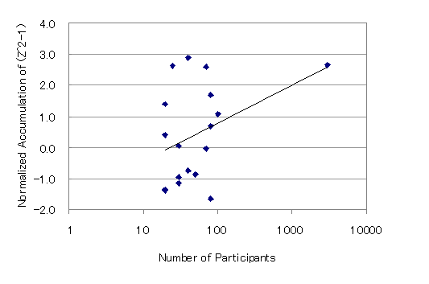
Fig. 1 Correlation between common logarithms of the number of participants and the normalized accumulation of (Z²-1) of 18 experimental data

Experimenter Effect
The “experimenter effects” among four experimenters were not clear. The numbers of significant results (accumulation of Z²-1, 5% level) of every experimenter were as follows: Hirukawa 2/10 (20%), Kokubo 2/7 (29%), Hiraoka 2/6 (33%), Silva 1/2 (50%), Pilato 0/1 (0%), and Total 6/26 (23%).

Patterns of the Deviation Graph
The “decline effects” have been reported in the experiments to detect PK. These may be reflection of the motivation of the subjects. In the field research of rituals and festivals, mountain shaped graphs (“up, up, and down” patterns) are commonly observed in the analyses of accumulation of (Z²-1). We also commonly find the peak of deviation in the latter half or even after the end of event although it is difficult to determine the exact time of the beginning and ending. Fig. 2 and 3 are typical (but arbitrarily selected) examples. These are the welcome ceremony of Guarani and the concert of Djavan.

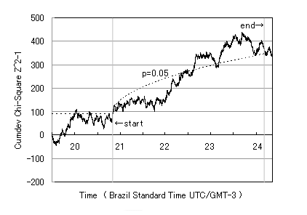
Fig. 2. Cumulative deviation of (Z²-1) of the welcome ceremony of Guarani people in Quatro Barras, 23-24/ April/ 2004.

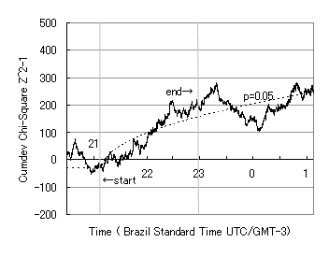
Fig. 3. Cumulative deviation of (Z²-1) of the live concert of Djavan in Curitiba, 3-4/ September/ 2004.

In fig. 3, the peak was observed 20 minutes after the end of concert.
Fig. 4 is another example from another series of experiments of the Nebuta-matsuri: summer festival in Japan (Hirukawa & Ishikawa, 2004). The shapes of graphs are similar to those of this study. The shape of graph is like a mountain and the peak is observed in the latter half of the event.

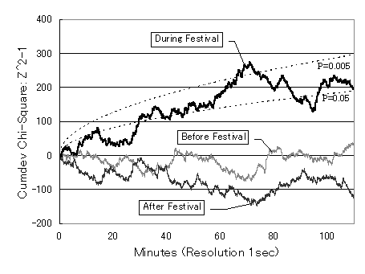
Fig. 4. Cumulative deviation of (Z²-1) of the Nebuta-matsuri: summer festival in Aomori, Japan, 2-3/ August/ 2003 (Hirukawa & Ishikawa, 2004)

Even if the total result from start to end of the event was not significant, the same patterns of deviations were often observed. Fig. 5 shows the most impressive example, the deviation of REG output in the tea ceremony of Santo Daime at Ceu do Paraná in April, 2004.

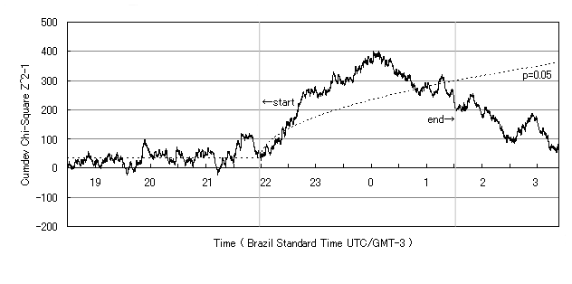
Fig.5. Cumulative deviation of (Z²-1) in the service at Ceu do Paraná, church of Santo Daime, at Batéias, 25-26/ April/ 2004

In this case, Hirukawa, the first author started to record of REG output at Ouro Verde Hotel in the center of Curitiba city, and arrived at Ceu do Parana about one hour before the ceremony. The deviation was fluctuating around zero before the beginning the service, and after that the participants took ayahuasca tea, the value of cumlative deviation of (Z²-1) started to increase and up to the peak the latter half of the ceremony when the participants were standing and singing hymns like “subi, subi, subi…(up, up, up…)”. And then the deviation changed to decrease and the total result at the time of ending of service was not significant in 5% level. However, Fig. 5 shows rather typical pattern of the deviation of the field REG experiments than the experiment with significant results.
We need new method to evaluate this pattern of data. One simple idea is evaluating the cumulative deviation to just the middle time of the total event. For instance, in the case of Fig. 5, the service began at 22:00 and ended at 25:30. The length was 210 minutes, so, the middle time is 105 minutes after 22:00, i.e. 23:45. At this time, Z=-1.33 (p=0.183), accumulation of (Z²-1)=293.0 (p=0.0045). We can recalculate other data, but we never do it more in this paper, because this is a kind of post hoc analysis.

Field REG and Global Consciousness Project
To check the fluctuations of “field consciousness” decline depend on the distance more globally, we can utilize the global network of REGs: the Global Consciousness Project (Nelson, 2001). The GCP built a worldwide network of REGs connected by Internet. (Hirukawa, the first author keep a REG site running at Meiji University in Tokyo, which is the only site of GCP in Japan as of today.) The GCP data showed significant deviation during some global events such as earthquakes, sports events, wars etc. (Radin, 2002; Nelson, 2002; see also website of GCP: http://noosphere.princeton.edu/results.html about current results). In addition, Radin et. al. (2004) suggest that a local healing session had effects on remote REGs of GCP and the effects declined along the distance. Further researches combining local Field REG experiments and the data of GCP are required to know more about the nature of “field consciousness”.

Acknowledgements

Authors thank Dr. Dean Radin, Institute of Noetic Science for allowing us to use a beta version of Field REG Device (FRED) code, and all the members of the group we investigated, Candomblé, Guarani people, Santo Daime, Umbanda, Faculdades Integradas “Espírita”, and other people contributed for the 2nd psi meeting. We wish also to acknowledge Masato Ishikawa, Meiji University for helpful discussion, and Toshimi Ueda, Kyoto University of Foreign Studies for the translation between Portuguese and English.

References

Bierman, D. J. (1996). Exploring correlations between local emotional and global emotional events and the behavior of a random number generator. Journal of Scientific Exploration, 10, 363-373.
Blackmore, S. (2003). Consciousness: An Introduction. London: Hodder & Stoughton.
Hirukawa, T. & Ishikawa, M. (2004). Anomalous fluctuation of RNG data in Nebuta: Summer festival in northeast Japan. Proceedings of Presented Papers, 47th Annual Convention of the Parapsychological Association, 389-398.
Nelson, R. D. (2001). Correlation of global events with REG data: An Internet-based, nonlocal anomalies experiment. Journal of Parapsychology, 65, 247-271.
Nelson, R. D., Bradish, G. J., Dobyns, Y. H., Dunne, B. J. & Jahn, R. G. (1996). FieldREG anomalies in group situations. Journal of Scientific Exploration, 10, 111-141.
Nelson, R. D., Jahn, R, G., Dunne, B. J., Dobyns, Y. H. & Bradish, G. J. (1998). FieldREG II: Consciousness field effects: Replications and explorations. Journal of Scientific Exploration, 12, 425-454.
Radin, D. I. (1997). The conscious universe. San Francisco: HarperEdge.
Radin, D. I. (2002). Exploring relationships between random physical events and mass human attention: Asking for whom the bell tolls. Journal of Scientific Exploration, 16, 533-548.
Radin, D. I., Rebman, J. M. & Cross, M. P. (1996). Anomalous organization of random events by group consciousness: Two exploratory experiments. Journal of Scientific Exploration, 10, 143-168.
Radin, D. I., Taft, R. & Yount, G. (2004). Possible effects of healing intention on cell cultures and truly random events. Journal of Alternative and Complementary Medicine, 10, 103-112.
Yoichi, H., Kokubo, H. & Yamamoto, M. (2002). Anomaly of random number generator outputs: Cumulative deviation at a meeting and New Year's holiday. Journal of International Society of Life Information Science, 20(1), 195-201.
Yoichi, H., Kokubo, H. & Yamamoto, M. (2004). Anomaly of random number generator outputs (II): Cumulative deviation at New Year's holiday. Journal of International Society of Life Information Science, 22(1), 142-146.

